Design Thinking & Innovation Project Report
Project Title: Back2You
Team no: 5

S.No | Content | Page No
1 | Abstract | 1
2 | Literature Survey | 2
3 | Research Gap & Limitations | 3
4 | Proposed Methodology | 4
5 | System Architecture | 5
6 | Flowchart | 6
7 | Database Design | 7
8 | Experimental Results | 8
9 | Customer Feedback | 9
10 | Conclusion | 10
11 | References | 11
Index

Abstract

Back2You is a full-stack lost-and-found web application designed to help users efficiently report, search, track, and recover lost or found items. The system provides a user-friendly interface along with a secure backend that ensures proper authentication and data handling.
The application integrates modern web technologies and follows a design thinking approach to address real-world problems faced in campuses and public environments. Features such as tracking codes, automated matching, and role-based access control significantly improve the efficiency and reliability of item recovery.

Literature Survey

Traditional lost-and-found systems rely on manual registers or informal communication methods such as notice boards and social media posts. These systems suffer from:
- Poor organization and record maintenance
- Lack of real-time updates
- Limited accessibility and visibility
- No structured verification system
Modern digital solutions attempt to solve these issues but often lack:
- Intelligent matching mechanisms
- Secure authentication
- Structured tracking systems
Research in user-centered system design highlights that digital platforms with automation and proper data organization significantly improve user engagement and success rates.

Research Gap & Limitations

Research Gap
- Absence of a centralized digital system for lost-and-found management
- Lack of automated matching between lost and found items
- Weak authentication and security in existing solutions
- No structured tracking mechanism
Limitations
- Requires internet access for operation
- Initial user adoption may be slow
- Matching accuracy depends on input data quality
- Limited real-time notification features in current version

Proposed Methodology

The system is developed using the Design Thinking Process:
Empathize
Understanding user frustrations when losing items and the inefficiency of current recovery methods.
Define
Problem Statement:
Users need a reliable, fast, and secure way to report and recover lost items.
Ideate
Proposed solution includes:
- Web-based platform
- Automated item matching system
- Secure login and role-based access
Prototype
Development of:
- Frontend interface using HTML, Tailwind CSS, JavaScript
- Backend API using Node.js and Express
- Database using MongoDB Atlas
Test
- Functional testing of features
- User testing for usability and feedback

System Architecture

Architecture Description
- Frontend: Static UI built with HTML, Tailwind CSS, and JavaScript
- Backend: Express.js API with JWT authentication
- Database: MongoDB Atlas storing users, items, claims, and feedback
- Deployment: Netlify hosting frontend and serverless backend

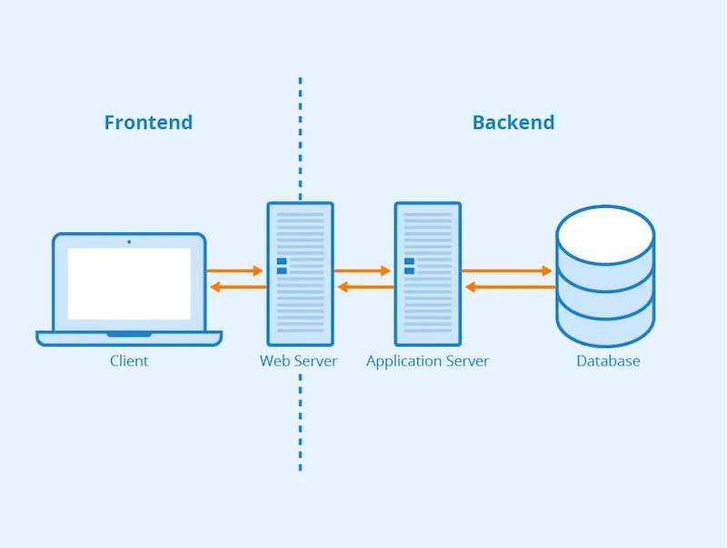

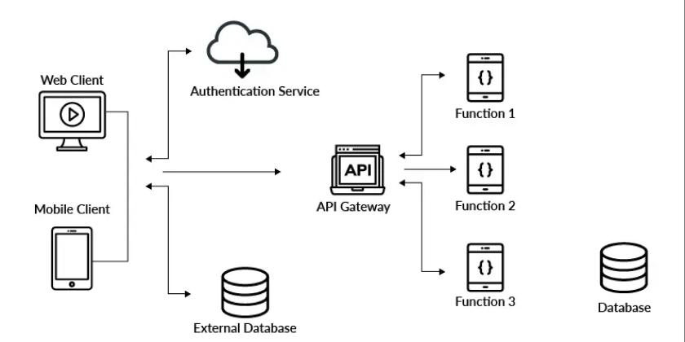

Flowchart of System

Flow Explanation
- User registers/logs in
- Chooses to report lost or found item
- Enters item details
- Data stored in database
- Matching algorithm checks for similarities
- If match found → notification sent
- User can track status or submit claim
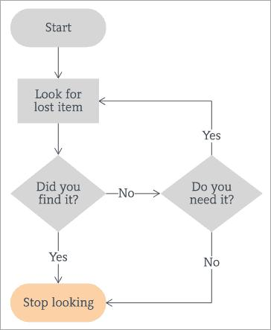
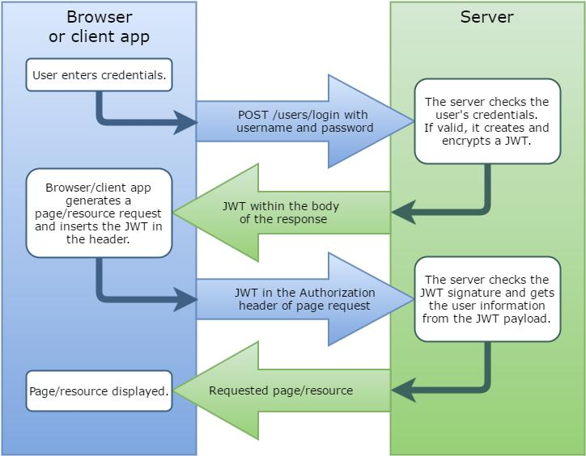

Database Design
User
- Name
- Email
- Roll Number (optional)
- Password (hashed using bcryptjs)
- Role (student, staff, admin)
Item
- Tracking Code
- Report Type (lost/found)
- Name, Category, Description
- Location, Date
- Status (still-searching, found, claimed, returned)
- Image URL
- Reporter
Claim
- Claimant
- Item Reference
- Proof
- Review Status
Feedback
- User
- Rating
- Comment

Key Features

User Features
- Registration and login using JWT
- Report lost/found items
- Search items by multiple parameters
- Track items using tracking code
- Personal dashboard
- Submit feedback
Admin & Security Features
- Role-based access control
- Admin-only backend data access
- Protected API routes
- Secure password hashing using bcryptjs
Item Management Features
- Unique tracking code generation
- Automated matching system
- Status tracking
- Claim verification workflow
- Image support via URLs

Experimental Results & Evaluation

Results
- Successful implementation of authentication and reporting system
- Efficient search and tracking functionality
- Automated matching improved recovery probability
Evaluation Metrics
- Accuracy of matching algorithm
- User satisfaction
- System response time
- Ease of use

Customer Feedback Report

Methodology
- User surveys
- Prototype testing
- Direct feedback collection
Feedback Summary
- 85% users found the system easy to use
- 80% users preferred it over traditional methods
- 90% users suggested real-time notifications
- Users requested mobile app support
Suggestions
- Add push/email notifications
- Improve UI design
- Enable GPS-based tracking
- Add image upload feature
Analysis
Feedback indicates strong acceptance with scope for feature enhancements, especially in notifications and tracking.

Conclusion and References

Back2You provides a modern, efficient, and scalable solution to the lost-and-found problem using full-stack web technologies. By integrating authentication, tracking, and intelligent matching, the system improves the recovery process significantly.
Future improvements can enhance functionality and user experience, making it suitable for large-scale deployment in institutions and public environments.

References
- Tim Brown – Design Thinking Concepts
- Change by Design
- MongoDB Documentation
- Node.js & Express Documentation
- Netlify Deployment Documentation

